A Carry Over from the Field Dinners.
Since the cessation of the Field Dinners at Jimboomba in October 2016 a few old and bolds have been gathering at the Campsite at Barry Wright’s Jimboomba property each 6 months for a few days as a get-together to recall old times.
The camp site is still in good condition with electricity, a full kitchen, shower, mess area for meals, morning and afternoon teas etc, ladies and gents’ toilets and lots of space for campers and a large open fireplace.
The get-togethers have usually been planned so that an Association AGM or Committee Meeting can be attended during the period. On the Friday night guests who were prominent during the Field Dinners come along for a meal and reminisce.
The last of these was held from Thu 11th – Sun 14th April and photos taken on the Friday evening are attached. 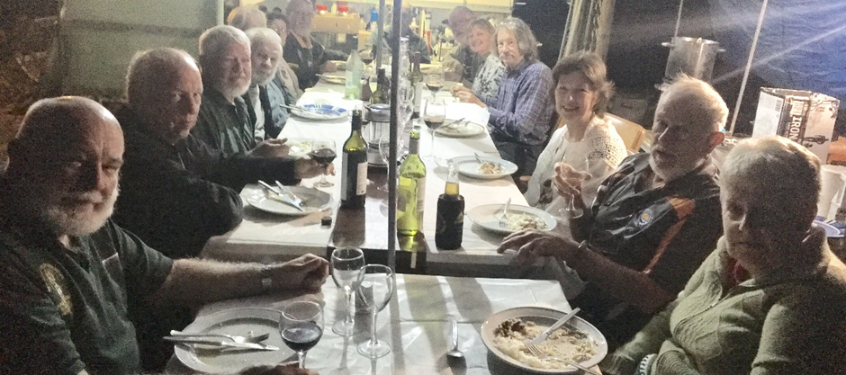
From L. Bob Collins, Glen O’Brien, Ian Thompson, Ted McAllan, Heather McAllan, Bernard Daniels, Barry Wright (at end) Tracee Trammell , Leigh Eastwood, Andrea Williams, Kerry and Elaine Glover.
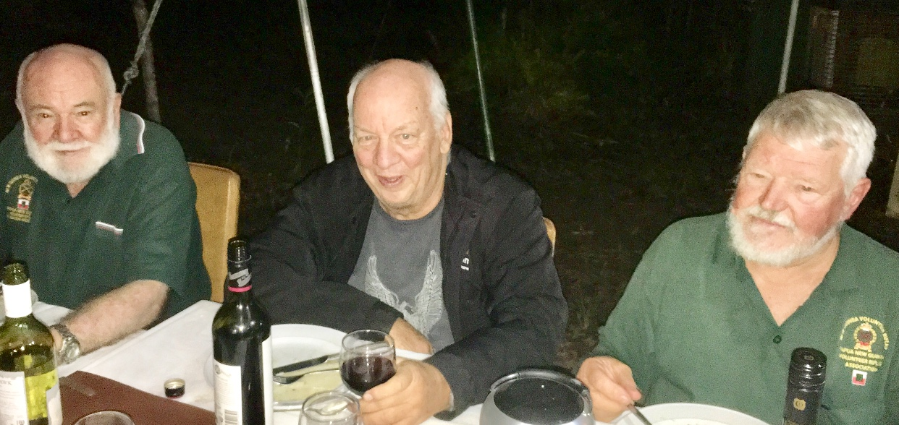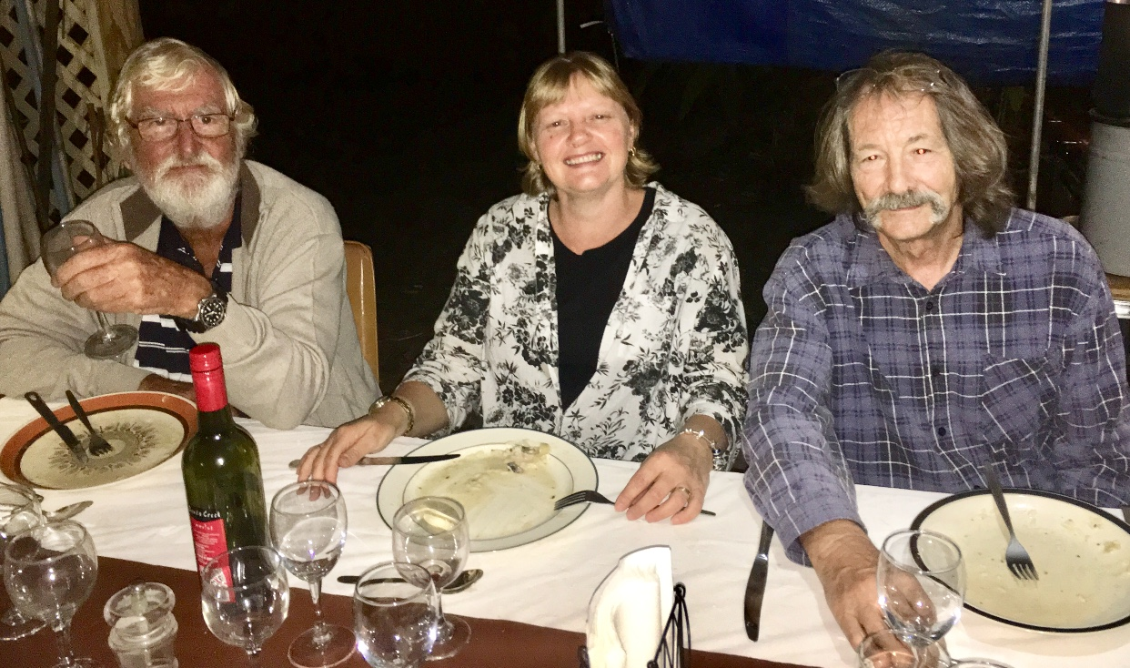
Bob Collins Glen O’Brien, Ian Thompson.
Bernard Daniels, Tracee Trammell, Leigh Eastwood.

